INSTALLATION INSTRUCTIONS
- https://www.oracle.com/java/technologies/javase-downloads.html
Download and Install Oracle Java JDK using the link above
- https://courses.missouristate.edu/KenVollmar/MARS/download.htm
Download MARS V4.5, Aug. 2014 using the link above

RUNNING THE CODE
Follow the Step (a) to (f) outlined below:
- Double Click the MARS jar file Downloaded. It should open to something like this
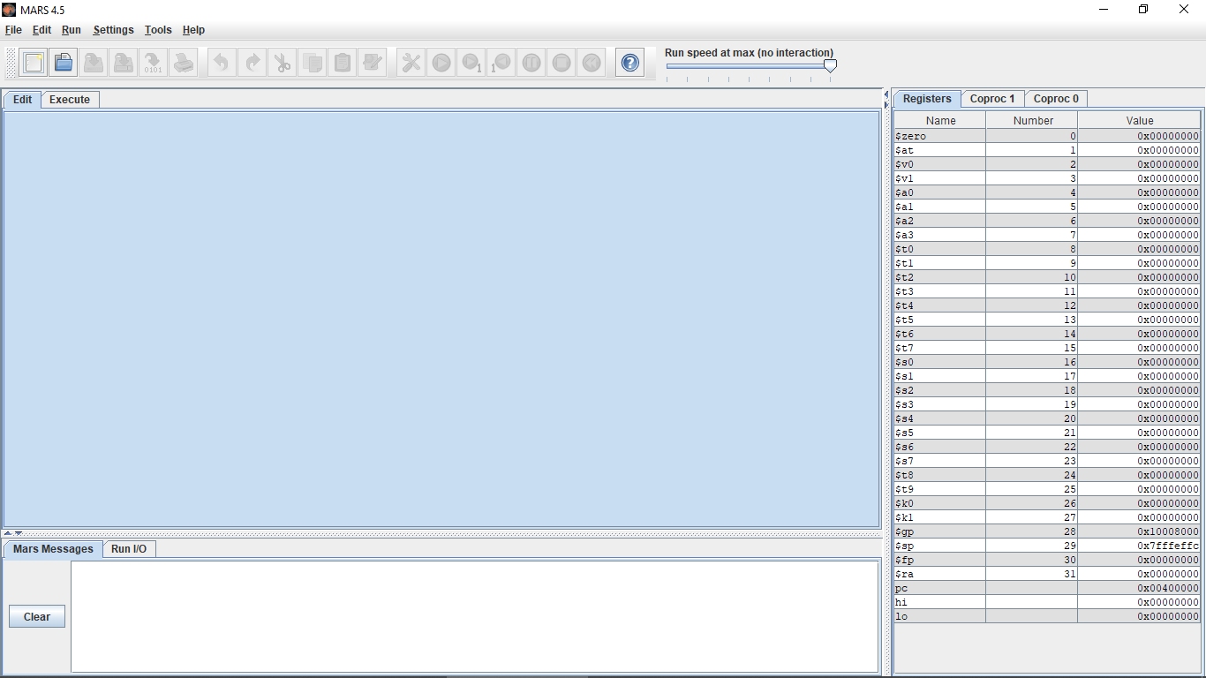

- Got to Files Option >> Open >> Navigate your Computer files to the place where you have saved “yourname_Sorting.asm” file and Open "yourname_Sorting.asm"
It should open the file as shown below:
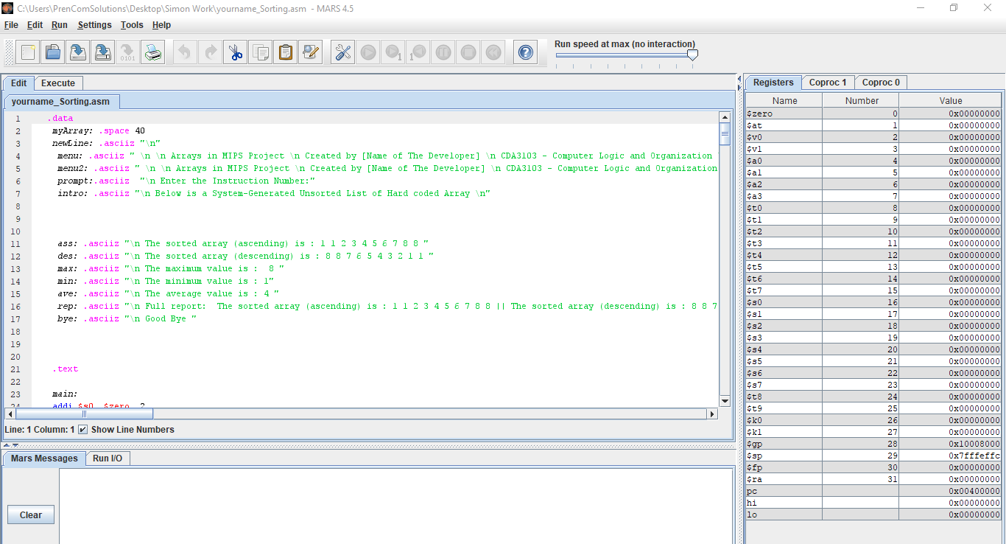

- To run the code, click on the “Tools Icon” to Compile the Code as shown below
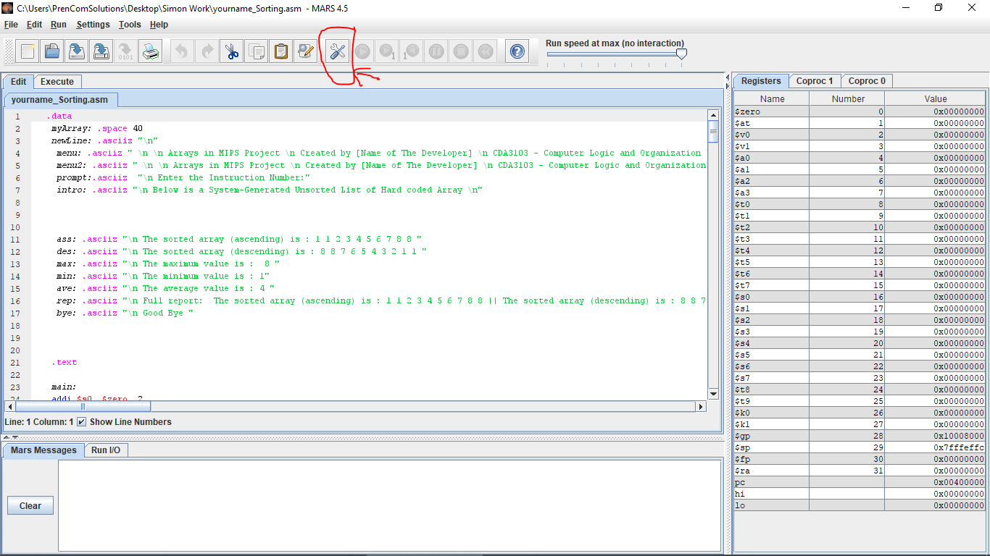

- Run the file by clicking on the “Run Icon” as shown below
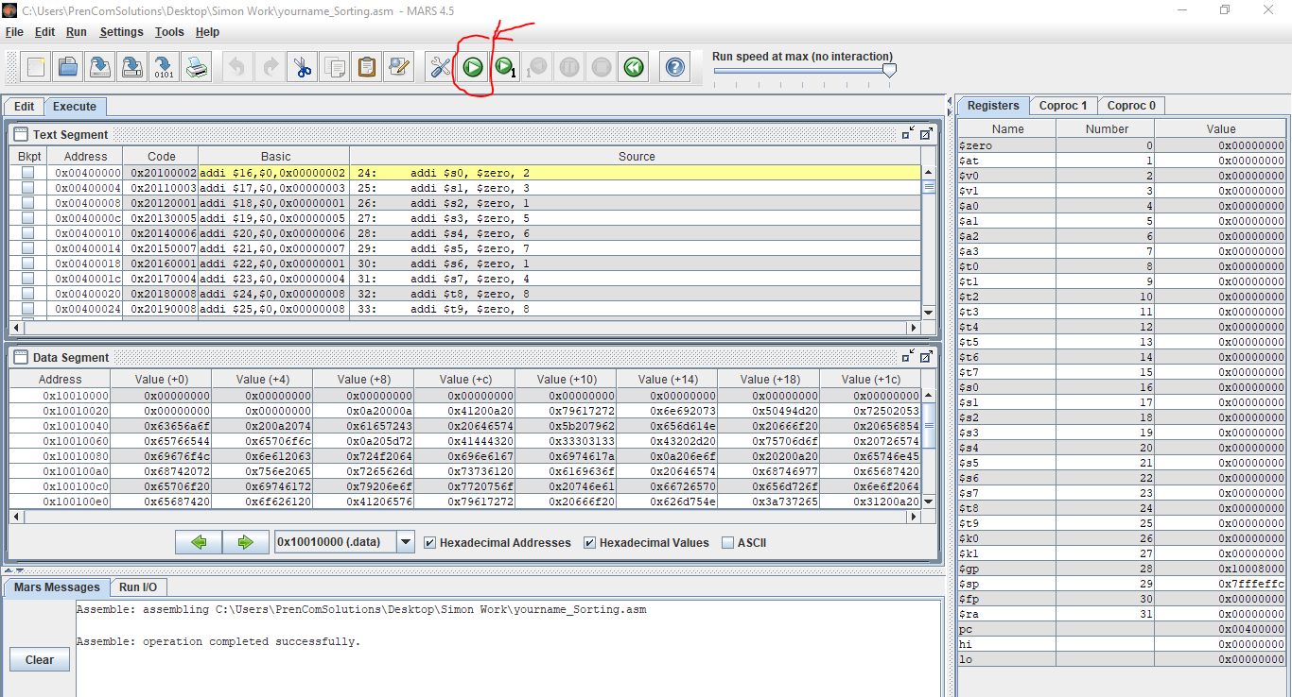

- On the Results Section (The bottom section of the window) Enter the Instruction’s Number you wish to run (e.g. 1 or 2 or 3 or 4 or 5 etc.) as shown below
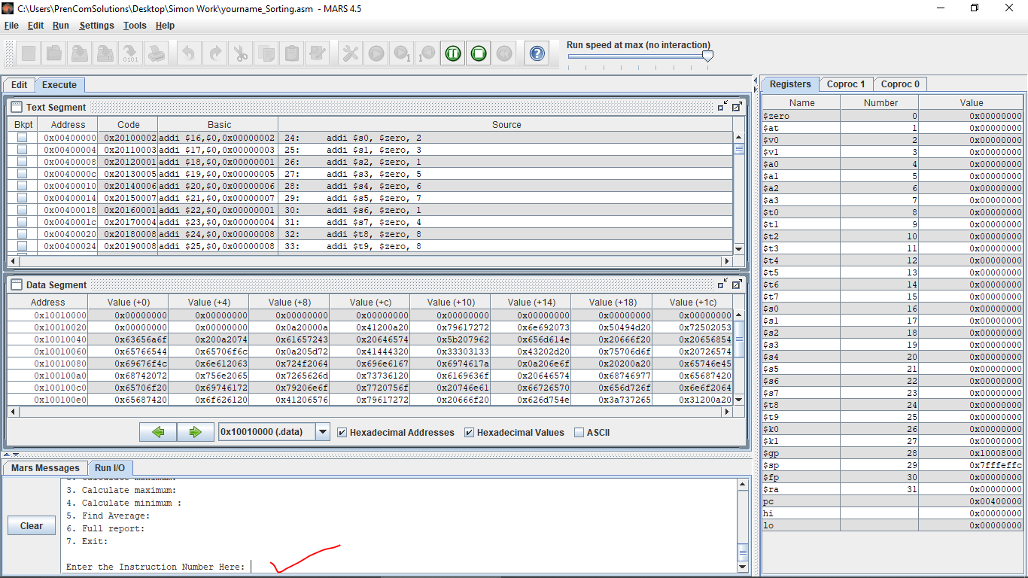

- The results should look something like this (at the bottom section)
